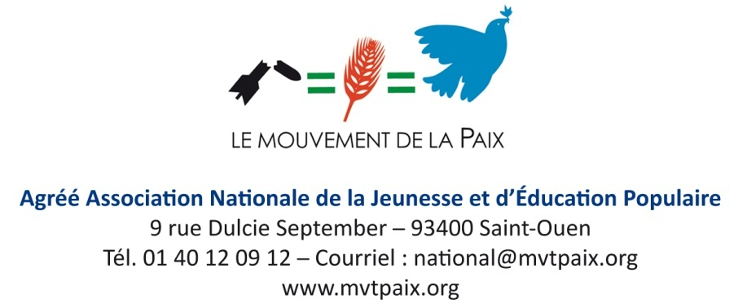

**__________________________________________________________________________  
  
Statement by the National Council of Le Mouvement de la Paix**  
France can and must play a role in the political and peaceful resolution of the "Korean crisis"

Le Mouvement de la Paix unequivocally condemned North Korea's willingness as soon as the 19th of July 2017, through various missile or nuclear tests, to develop the potential for nuclear weapons and intercontinental missiles. The latest test of September the 3rd is a new step in irresponsibility.

For Le Mouvement de la Paix, the urgency is to find a political solution. To this end, the reciprocal provocations between US and the Democratic People's Republic of Korea must cease.

While the North Korean government must immediately stop all nuclear tests and missile launches, it is also necessary for all parties involved to stop any provocation, whether through military exercises or the determined will to create new military bases (ex USA near Okinawa) and to put on the table of negotiations, the establishment for this region of Nuclear-Weapon-Free Zones (NWFZ).

The Iranian crisis has been resolved politically. The same must be true of the current crisis.

Le Mouvement de la Paix believes that France, as a nuclear power, can contribute to this political solution by:

• acting diplomatically with the United Nations to commit all nuclear-weapon States, including France, to ratifying the Treaty on the Prohibition of Nuclear Weapons adopted at the United Nations on the 7th of July 2017 and subject to ratification at the United Nations as soon as the 20th of September 2017.

• Immediately freezing the programs for the modernization of its nuclear weapons, for which a doubling of budgetary allocations is foreseen by 2020. These programs constitute a violation of the Treaty on the Non-Proliferation of Nuclear Weapons (NPT) signed by France, which provides in his Article 6th that: *"Each of the parties to the Treaty undertakes to pursue in good faith, negotiations on effective measures relating to the cessation of the nuclear arms race at an early date and to nuclear disarmament ".*

We expect to the President of the French Republic and the Government to give a strong signal of their will to respect and enforce the international law to end this aberrant situation which results in 9 States, in the name of deterrence and in violation of international law, have accumulated nearly 17,000 nuclear bombs (8,000 in the US, 7300 in Russia, 300 in France, 250 in China, 200 in the UK, 110 in Pakistan, 100 in India, 80 by Israel, and 3 or 4 by North Korea).

It is not possible that States violate consistently the rules they intended to be respected by all other States. The solution to this crisis is in the strict application of international law which establishes the illegality of mass destruction weapons including nuclear weapons and through the negotiated resolution of conflicts advocated by the Charter of the United Nations.

The peace marches will take place in many localities in France on Saturday, the 23d of September 2017, which as part of the International Day of Peace, will be a tool available to all, to demand to cease this dangerous logic for peace and which threatens the survival of humanity.

These marches will be a means for all, to express our common aspiration to live in a world of justice, solidarity, fraternity and peace.

**Paris, The 13d of September 2017,  
Le Mouvement de la Paix  
[National Council from the 10th of September 2017 in Créteil]**